# Using the Distance Formula

Derived from the Pythagorean Theorem, the distance formula is used to find the distance between two points in the plane. The Pythagorean Theorem, $a^{2}+b^{2}=c^{2}$ , is based on a right triangle where $a$  and $b$  are the lengths of the legs adjacent to the right angle, and $c$  is the length of the hypotenuse.

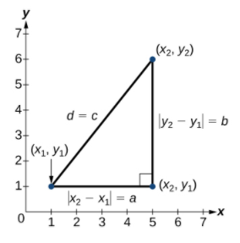

Rather than using $a$, $b$, and $c$, we use $x$ and $y$ since we are on the coordinate plane. The symbols $\left|x_{2}-x_{1}\right|$ and $\left|y_{2}-y_{1}\right|$  indicate that the lengths of the sides of the triangle are positive.

To find the length $c$ , take the square root of both sides of the Pythagorean Theorem.

$$c^{2}=a^{2}+b^{2}→c=\sqrt{a^{2}+b^{2}}$$

Similarly, to find $d$, which represents the distance of side $c$,

$$d^{2}={(x_{2}-x_{1})}^{2}+{(y_{2}-y_{1})}^{2}→d=\sqrt{{(x_{2}-x_{1})}^{2}+{(y_{2}-y_{1})}^{2}}$$

Given endpoints $\left(x_{1},y_{1}\right)$ and $\left(x_{2},y_{2}\right)$, the **distance** between two points is given by

$$d=\sqrt{{(x_{2}-x_{1})}^{2}+{(y_{2}-y_{1})}^{2}}$$

Examples: For each of the following, find the distance between the two points given.

1. $(-3,-1)$ and $(2, 3)$
2. $(1, 4)$ and $(11, 9)$

# Using the Midpoint Formula

When the endpoints of a line segment are known, we can find the point midway between them. This point is known as the midpoint and the formula is known as the midpoint formula.

Given the endpoints of a line segment, $\left(x_{1},y_{1}\right)$ and $\left(x_{2},y_{2}\right)$, the **midpoint formula** shows how to find the coordinates of the midpoint $M$.

$$M=\left(\frac{x_{1}+x_{2}}{2},\frac{y_{1}+y_{2}}{2}\right)$$

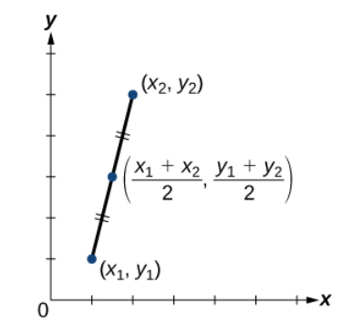

Notice that the line segments on either side of the midpoint are congruent.

Examples:

1. Find the midpoint of the line segment with the endpoints $(7,-2)$ and $(9, 5)$.
2. The diameter of a circle has endpoints $(-1,-4)$ and $(5, -4)$. Find the center of the circle.